fib International Symposium on Conceptual Design of Concrete Structures Oslo 2023

INSTRUCTIONS TO AUTHORS FOR
Full Paper deadline for the congress is 27th of March 2023

Submit your Full Paper here
ACKNOWLEDGEMENT:
These instructions have been derived from instructions for various conference proceedings.
If you have any questions regarding the paper/presentation or contest, please contact us at fibcdoslo2023@tekna.no
FULL PAPER FORM, FONT, ECT:
The full paper must be formatted in Microsoft Word, single-spaced and using size 11 Times New Roman font.
The Full Paper must be submitted as an PDF file.
This sheet has been typed in accordance with the style to be followed, in Times New Roman 11 points.
Full paper should be maximum ten (10) A4 pages, including figures, references, etc.

KEYWORDS:
Indicate main and subtopic words

LANGUAGE:
All papers must be written and presented in English only. It is advisable, especially for non-English speaking authors, to make sure that the language used is correct and appropriate. No simultaneous translation will be provided or allowed.

PRESENTATION:
Scheduled time for oral presentation of each paper is 15 minutes + 5 min. to questions from the audience for all presentation at the end of each session. The chair­persons of each session will decide on the organization of their session. It is essential that at least one author registers for the Conference to present the paper personally and participate in the discussion, or else the paper will not be a part of the conference.

TECHNICAL REQUIREMENTS FOR THE MANUSCRIPTS – PUBLICATION:
Proceedings will be available on a online link after the Conference.
The final papers will be copied directly from the submitted and approved manuscripts.
The copyright and responsibility of the content of the papers will be the property of the authors.
The Norwegian Concrete Association will have the right to print and publish the proceedings at the conference and to sell extra copies after the conference. To ensure that papers will be reproduced clearly and in proper size and form, and that they will conform with the general layout of the Proceedings publication, authors should carefully observe the following instructions.

MANUSCRIPTS MUST BE TYPED ACCORDING TO THIS MODEL:
Title
The TITLE should be as short as possible but describe the paper sufficiently to distinguish it from others. Write the title in capital letters centred on the page.

Authors
The author(s) must be identified immediately following the title by first name, (middle name initial) and surname (family name). Underline your surname or the part of your name by which it should appear in the alphabetized index. Write your affiliation and country centred under your name.

Abstract
Add an Abstract, starting two lines below authors, underline and in bold. Divide the text into sections if you wish, with clearly indicated headings and sub-headings.

Headings
Write MAJOR HEADINGS in capital letters on a separate line flush left; use bold typeface, if available. Write sub­headings in ordinary letters flush left on separate line; use bold typeface, if available. Leave two empty lines before every major heading or subheading and one empty line before starting a new paragraph. If a second level of subheadings is used, it should be in italics with one line of spacing above and none below. Text within tables might be of type size 10

Page Numbers
Do not type page numbers. Page numbers running in sequence throughout the volume will be added prior to printing.

Symbols and Abbreviations
Unusual technical terms should be defined as they occur. Use only standard symbols and abbreviations in text and illustrations. Acronyms must be given in full at their first appearance - remember that an acronym which you consider obvious, may not be understandable to all.

Units
SI units are preferred. If US units are used, please add SI units in parentheses.

Tables and figures
Place tables and figures fully inside the margins and in context with accompanying explanatory legends or texts under figures and over tables. The quality of the figures/illustrations is essential.
Number figures and tables separately. Captions should be in italics and spaced one line from the adjacent paragraph.
Examples of a table and a figure are given below:
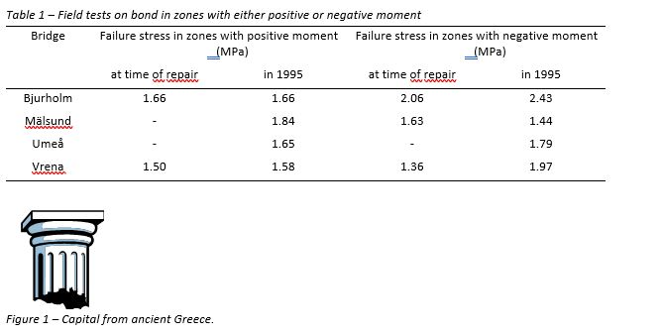

REFERENCES:
References should be numbered consecutively as they appear in the text within brackets (i.e. [1]) and listed at the end of the paper under the major heading References. Full bibliographic details should be given according to normal scientific standards, for example:

- Biedenbach, J.M. "Developing Proceedings for Conferences-Nuts and Bolts". Proceedings Third world Conference on Continuing Engineering Education, May 7-9 1986, Lake Buena Vista, Florida. ASEE, IEEE, 1986.
If you have any questions about the paper/presentation, please contact: fibcdoslo2023@tekna.no

